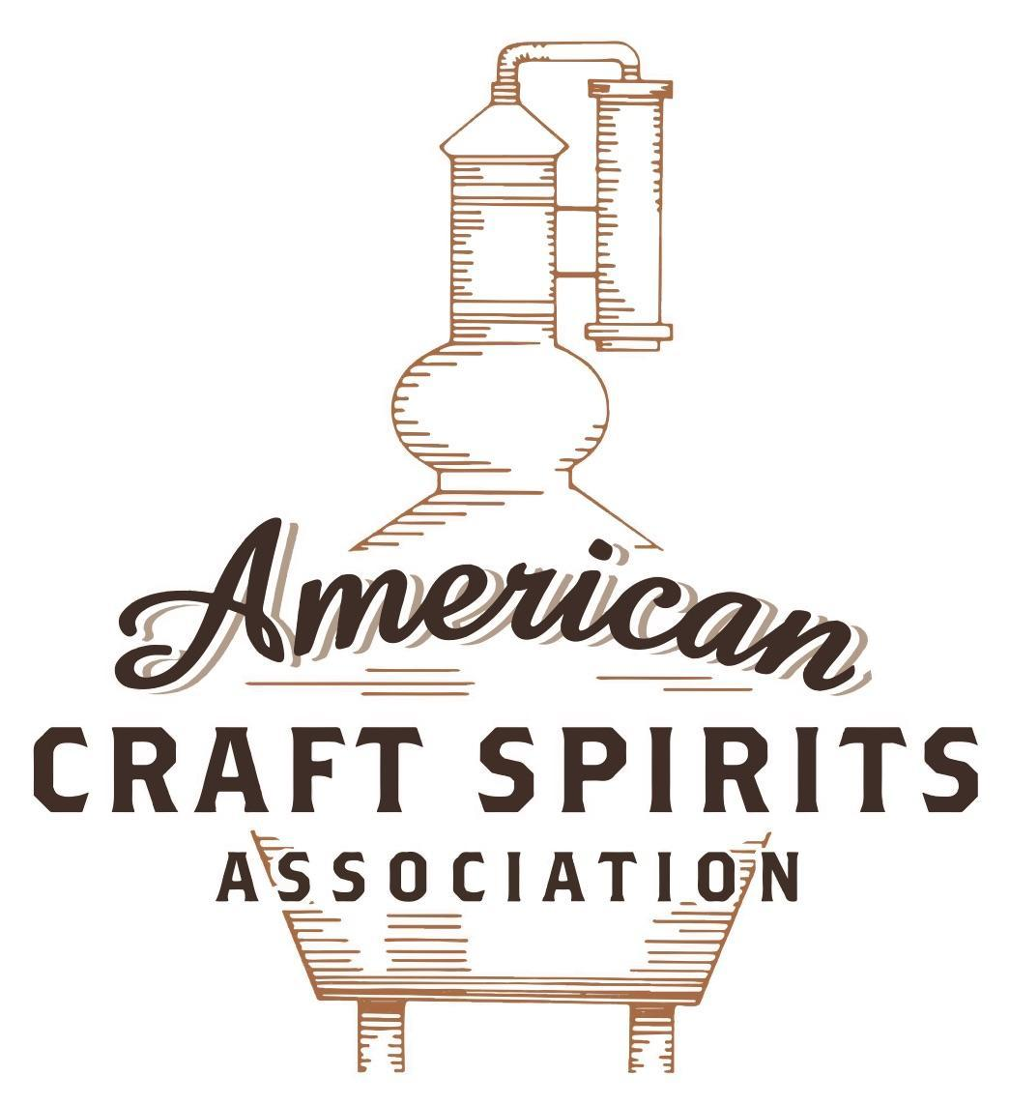
Spirits DtC Shipping Guide

This guide summarizes the direct-to-consumer shipping rules for distilleries in all 50 states and D.C. and also addresses the measures state governments have taken to ease delivery and shipping restrictions during the COVID-19 pandemic.

DtC Quick Guide Comparison

Out-of-State Distilleries  Can Ship Into State? |  |  |  | In-State Distilleries  Can Ship Within State?
State | Yes | No |  | State | Yes | No
AL |  | X |  | AL |  | X
AK | X |  |  | AK | X
AZ | X |  |  | AZ | X
AR |  | X |  | AR |  | X
CA |  | X* |  | CA |  | X*
CO |  | X |  | CO |  | X
CT |  | X* |  | CT |  | X
DE |  | X |  | DE |  | X
DC | X |  |  | DC | X
FL |  | X |  | FL |  | X
GA |  | X |  | GA |  | X
HI |  | X* |  | HI |  | ?*
ID |  | X |  | ID |  | X
IL |  | X* |  | IL |  | X*
IN |  | X |  | IN |  | X
IA |  | X* |  | IA |  | X*
KS |  | X |  | KS |  | X
KY | X |  |  | KY | X
LA |  | X |  | LA |  | X
ME |  | X* |  | ME |  | X*
MD |  | X |  | MD |  | X
MA |  | X |  | MA |  | X
MI |  | X |  | MI |  | X
MN |  | X |  | MN |  | X
MS |  | X |  | MS |  | X
MO |  | X |  | MO |  | X
MT |  | X |  | MT |  | X
NE | X |  |  | NE | X
NV |  | X* |  | NV |  | X
NH | X |  |  | NH |  | X*
NJ |  | X* |  | NJ |  | X*
NM |  | X |  | NM |  | X
NY |  | X* |  | NY |  | X*
NC |  | X |  | NC |  | X
ND | X |  |  | ND | X
OH |  | X |  | OH |  | X
OK |  | X |  | OK |  | X
OR |  | X |  | OR | X
PA |  | X* |  | PA |  | X
RI |  | X* |  | RI |  | X
SC |  | X |  | SC |  | X
SD |  | X |  | SD |  | X
TN |  | X |  | TN |  | X
TX |  | X |  | TX |  | X
UT |  | X |  | UT |  | X
VT |  | X |  | VT |  | X
VA |  | X |  | VA |  | X
WA |  | X* |  | WA | X
WV |  | X* |  | WV |  | X*

WI |  | X |  | WI |  | X
WY |  | X |  | WY |  | X

Notes:
*CA: If passed and signed into law, Senate Bill 620 would allow licensed distilled spirits producers in states other than California and licensed distilled spirits manufacturers or craft distillers in California who obtain distilled spirits direct shipper permits to ship directly to consumers in California
*CT: Consumers with appropriate permit may receive alcohol shipments
*HI: Consumers with appropriate permit may receive alcohol shipments; If passed and signed into law, Senate Bill 65 would allow licensed distilled spirits manufacturers in Hawaii and in states other than Hawaii who obtain direct shipper permits to ship directly to consumers in Hawaii
*IL: If passed and signed into law, Senate Bill 0532 would allow licensed distilled spirits producers in Illinois and in states other than Illinois who obtain distillery shippers’ licenses to ship directly to consumers in Illinois
*IA: If passed and signed into law, House File 639 would allow native distilled spirits manufacturers in Iowa and in states other than Iowa who obtain direct shipper permits to ship directly to consumers in Iowa and to consumers in states other than Iowa
*ME: If passed and signed into law, Legislative Document 1358 would allow distilleries outside of Maine with current manufacturer licenses and distilleries licensed in Maine who obtain spirits direct shipper licenses to ship directly to consumers in Maine
*NJ: (1) If passed and signed into law, Assembly Bill 3167 would allow a craft distillery licensees to ship no more than 9 liters of distilled spirits to a consumer in New Jersey; (2) If passed and signed into law, Senate Bill 3020 would allow craft distillery licensees in New Jersey or in states other than New Jersey to ship no more than 20 liters of distilled spirits to a consumer in New Jersey via common carrier
*NV: Licensed individuals can import one gallon per month of spirits for personal use and the out-of-state supplier must pay excise tax
*NH: If passed and signed into law, Senate Bill 125 would allow licensed liquor manufacturers who obtain direct to consumer shipping permits from the commission to ship directly to consumers in New Hampshire
*NY: Consumer may import up to 90L of liquor per year for personal use without a license; If passed and signed into law, Assembly Bill 3275 would allow licensed liquor manufacturers in states other than New York and licensed distillers and farm distillers in New York to ship no more than thirty-six cases (no more than nine liters per case) of liquor to consumers in New York
*PA: Consumer may place a special liquor order and distiller must ship to a PLCB-operated store
*RI: Distiller can only ship to customer if order was personally placed by customer at distiller's premises
*WA: If passed and signed into law, House Bill 1432 would allow licensed spirits manufacturers in states other than Washington to ship spirits to consumers in Washington
*WV: Distilleries, mini-distilleries, or micro-distilleries licensed in West Virginia or a state other than West Virginia who obtain private direct shipper licenses to ship to a consumer in West Virginia, however the shipments must be made to a retail liquor outlet

KENTUCKY
Shipment Outbound – Silent.
Shipment Inbound – Yes, with a direct shipper license (Ky. Rev. Stat. § 243.027; 804 KAR 4:415).
Shipment Intra-state – Yes, see above.
COVID-19 Measures – Alcoholic beverage licenses expiring on or before September 30, 2020, will remain in effect and authorize alcoholic beverage sales until October 31, 2020. Licensees must submit license renewal applications to continue alcoholic beverage sales thereafter. No further extensions will be granted, barring exigent circumstances.
Link: http://abc.ky.gov/Documents/ABC%20-%20Supplemental%20Order%20re%20license%20renewals.pdf
Citation (shipment)
Kentucky Revised Statutes
§ 243.027. KRS 243.027 to 243.029 supersedes any conflicting provision of KRS Chapters 241 to 244—Licensing of direct shippers of alcoholic beverages—Duties of direct shipper licensees—Administrative regulations—Use of third parties to ship—Shipping of samples.
(2) A direct shipper license shall authorize the holder to ship alcoholic beverages to consumers. The department shall issue a direct shipper license to a successful applicant that:
(a) Pays an annual license fee of one hundred dollars ($100);
(b) Is a manufacturer located in this state or any other state or an alcoholic beverage supplier licensed
under KRS 243.212 or 243.215; and
(c) Holds a current license, permit, or other authorization to manufacture or supply alcoholic beverages in
the state where the applicant is located. If an applicant is located outside of Kentucky, proof of its current
license, permit, or other authorization as issued by its home state shall be sufficient proof of its eligibility
to hold a direct shipper license in Kentucky.
(3) (a) A manufacturer applicant shall only be authorized to ship alcoholic beverages that are sold under a
brand name owned or exclusively licensed to the manufacturer, provided the alcoholic beverages were:
1. Produced by the manufacturer;
2. Produced for the manufacturer under a written contract with another manufacturer; or
3. Bottled for or by the manufacturer.
(b) An applicant licensed under KRS 243.212 or 243.215 shall only be authorized to ship alcoholic beverages
for which it is the primary source of supply.
(4) The department shall establish the form for a direct shipper license application through the promulgation of an administrative regulation. These requirements shall include only the following:
(a) The address of the manufacturer or supplier; and
(b) If the applicant is located outside this state, a copy of the applicant's current license, permit, or other authorization to manufacture, store, or supply alcoholic beverages in the state where the applicant is located.
(5) For purposes of this section, the holder of a direct shipper license may utilize the services of a third party to fulfill shipments, subject to the following:
(a) The third party shall not be required to hold any alcoholic beverage license, but no licensed entity shall
serve as a third party to fulfill shipments other than the holder of a storage license or transporter's license;
(b) The third party may operate from the premises of the direct shipper licensee or from another business
location; and
(c) The direct shipper licensee shall be liable for any violation of KRS 242.250, 242.260, 242.270, or 244.080
that may occur by the third party.

(6) A direct shipper licensee shall:
(a) Agree that the Secretary of State shall serve as its registered agent for service of process. The licensee
shall agree that legal service on the agent constitutes legal service on the direct shipper licensee;
(b) Maintain the records required under KRS 243.027 to 243.029 and provide the department and the
Department of Revenue access to or copies of these records;
(c) Allow the department or the Department of Revenue to perform an audit of the direct shipper licensee's
records or an inspection of the direct shipper licensee's licensed premises upon request. If an audit or
inspection reveals a violation, the department or the Department of Revenue may recover reasonable
expenses from the licensee for the cost of the audit or inspection;
(d) Register with the Department of Revenue, and file all reports and pay all taxes required under KRS
243.027 to 243.029; and
(e) Submit to the jurisdiction of the Commonwealth of Kentucky for any violation of KRS 242.250, 242.260,
242.270, or 244.080 or for nonpayment of any taxes owed.
(7) (a) Each direct shipper licensee shall submit to the department and the Department of Revenue a quarterly report for that direct shipper license showing:
1. The total amount of alcoholic beverages shipped into the state per consumer;
2. The name and address of each consumer;
3. The purchase price of the alcoholic beverages shipped and the amount of taxes charged to the
consumer for the alcoholic beverages shipped; and
4. The name and address of each common carrier.
(b) The Department of Revenue shall create a form through the promulgation of an administrative
regulation for reporting under paragraph (a) of this subsection.
(c) The department shall provide a list of all active direct shipper licensees to licensed common carriers on a
quarterly basis to reduce the number of unlicensed shipments in the Commonwealth.
(8) A direct shipper licensee shall submit a current copy of its alcoholic beverage license from its home state
along with the one hundred dollar ($100) license fee every year upon renewal of its direct shipper license.
(9) Notwithstanding any provision of this section to the contrary, a manufacturer located and licensed in Kentucky may ship by a common carrier holding a Kentucky transporter's license samples of alcoholic beverages produced by the manufacturer in quantities not to exceed one (1) liter of any particular product in one (1) calendar year of distilled spirits or wine, or ninety-six (96) ounces of any particular product in one (1) calendar year of malt beverages, to the following:
(a) Marketing or media representatives twenty-one (21) years of age or older;
(b) Distilled spirits, wine, or malt beverage competitions or contests;
(c) Wholesalers or distributors located outside of Kentucky;
(d) Federal, state, or other regulatory testing labs; and
(e) Third-party product formulation and development partners.
Such samples shall be marked by affixing across the product label, a not readily removed disclaimer with the words "Sample-Not for Sale" and the name of the manufacturer
Link: https://apps.legislature.ky.gov/law/statutes/statute.aspx?id=50669
Department of Alcoholic Beverage Control Regulations
804 KAR 4:415. Direct shipper license.
Section 1. Qualifications. To qualify for a direct shipper license, the applicant shall:
(1) Hold a current license, permit, or other authorization to manufacture alcoholic beverages in the state where it is located or a current license in this state under KRS 243.212 or 243.215 to supply alcoholic beverages;
(2) Hold a current permit or authorization under the Federal Alcohol Administration Act as follows:
(a) If a manufacturer other than a brewery, a basic permit to produce or manufacture beverage alcohol;
(b) If a manufacturer that is a brewery, a brewer’s notice to produce or manufacture malt beverages; or
(c) If an importer, wholesaler, or distributor licensed as a supplier under KRS 243.212 or 243.215, a basic importer’s or wholesaler’s permit for the purpose of directly shipping only those products for which the applicant is designated the primary source of supply under the applicant’s supplier license;
(3) Complete the online direct shipper license application via the department’s licensing portal at https://abc-portal.ky.gov/s/kyabcnewlicensetype;
(4) Provide the address and a description of the premises from which the applicant will ship alcoholic beverages to consumers, and documentation showing ownership or possession of the premises under a written agreement;
Link: https://apps.legislature.ky.gov/law/kar/804/004/415.pdf

The American Craft Spirits Association (ACSA) is working diligently to give our members and industry partners relevant, current updates on statutes and regulations impacting production, sale and distribution of spirits. With the declaration of the novel coronavirus (COVID-19) in early 2020, many states have issued temporary policy changes or longer-term modernization of alcohol beverage laws. State statutes, regulations created by the state alcohol regulatory authority, as well as any other relevant guidance provided by such authorities (such as advisories, opinions, bulletins, etc.) were reviewed in creation of this document. No city or county ordinances were reviewed. Distillers should be aware that even in states where direct shipping is permissible, always remember to avoid shipping to dry counties. Please consult with your state guild or alcohol beverage authority for the most up-to-date information. This content is intended for educational and informational purposes only. ACSA's pro bono law firm of Malkin Law P.A. provided the core content found in this comprehensive overview of the spirits distribution after COVID-19. It was completed in August 2021 and will be updated regularly. If you have updates you would like to provide, please send to legislation@americancraftspirits.org or directly to the law firm at: ryan@malkin.law / malkin.law. Thank you.

